

LinkedIn Grad - Start your career

Marketing Guide

## **Background**:

1. Background:

Research has shown that over 200 million students graduate each year, whereas just only 51% of them would be hired during 6 months after graduation (2020).

Approximately 100 million freshers would be unemployed, which brings several negative aspects to the economic development worldwide.

LinkedIn is an employment-oriented service, which is used for looking for professional job opportunities popularly in the world.

Recently, there are many similar platforms that focus on the new target users - graduated students every year.

2. Problem Statement

Nowadays, there has been an increasing number of companies, which provide job recommendations and excellent features for that mean of users.

Several graduated students have faced a lot of difficulties looking for their first job that is suitable with their professional skills as well as their expectation in the future. The primary reasons are a lack of soft skills like interview or negotiation, no experience in working environment in businesses and career path’s direction.

Struggles with freshers to start a professional career:

* *Lack of work experiences in enterprises’ environments*
* *Lack of soft-skills (interview, communication, …)*
* *Have no clear career paths*

3. Product Goals

* Build a system help users create and review resume
* Provide numerous online courses and certificate
* Apply AI in suggesting students’ profile to recruiters
* Recommend jobs

### 4. Key Features

1. **Resume**

* CV’s system for users to upgrade their resume with the suggestion from AI.
* This is a crucial feature to build the fundamental background for users and attract the recruiters.
* Increase the acceptance rate of the 1st round (CV)

1. **Online Course**

* Training courses provide a lot of information for freshers to enhance their professional skills (marketing, computer science,...) and their soft skills (interview, presentation, negotiation, …)
* This is a supportive foundation that helps college graduates be outstanding in the next stages.

1. **Job Recommendation**

* Based on the professional and soft skills as well as the created resume, there are several suggestions about the suitable jobs for students.
* This is a vital step in the process of applying for a job, which could have positive impacts on the result of acceptance rate.
* Feature allows freshers to access the potential career of their aspects and directs them to follow.

## **Market background:**

**Target Audience:**

### LinkedIn Grad will focus on freshers of the global workforce by providing the fundamental step for their career such as an excellent resume, advanced professional and soft skills and the suitable job recommendations.

### **Target Market**

### Total Addressable Market

200M students per year X $120 (annually) = $24B

**Potential Market:**

* China *(27% of global in 2030)*
* India *(23% of global in 2030)*
* US *(8% of global in 2030)*

Data Resource: [link](https://monitor.icef.com/2019/07/oecd-number-of-degree-holders-worldwide-will-reach-300-million-by-2030/)

### 

**Competitors**

1. Indeed (Data Source: [Link](https://comparecamp.com/indeed-com-review-pricing-pros-cons-features/))

| Product Available | * Website * Mobile Application |
| --- | --- |
| Features | * Resume builder * Job listing * Messaging * Email Job Alert |
| Target customers | * Worldwide market |
| Differentiators | * Schedule and conduct virtual interview * Free trial (unlimited) |
| Price | * Free (or starting 5$ for job posters) |

1. Glassdoor (Data source: [Link](https://www.getapp.com/hr-employee-management-software/a/glassdoor/))

| Product Available | * Website * Mobile Application |
| --- | --- |
| Features | * Listing jobs * Personal branding * Review company * Access salary databases |
| Target consumers | * Worldwide users |
| Differentiators | * Job satisfaction rate |
| Price | * Free |

## **Product Background and Positioning:**

Mobile application named LinkedIn Grad provides many features related to enhancing freshers’ skills and preferences. Several benefits can be reaped from our application such as job recommendations, creating and reviewing resumes, and online courses.

**Premium features:**

* building profiles and networks
* creating resumes
* applying for jobs.
* Reviewing resumes by AI systems
* Online courses
* Certificates
* Job recommendations.

**Differentiators:**

| LinkedIn CV | * Allow students to create CV actively * Increase the amount of CVs on the system |
| --- | --- |
| LinkedIn Online course | * Provide freshers professional knowledge to adapt real working environment in businesses * Improve soft skills *(negotiation, interview, presentation, …)* |
| Suggest employees’ profile | * Boost the efficiency of recruitment * Strengthen connection between company and employees |
| Jobs recommendation | * Use AI to optimize the most suitable chances |

**User supports**

Users can download the app from Google Play Store for android OS and App Store for iOS easily and conveniently.

**How to register and login**

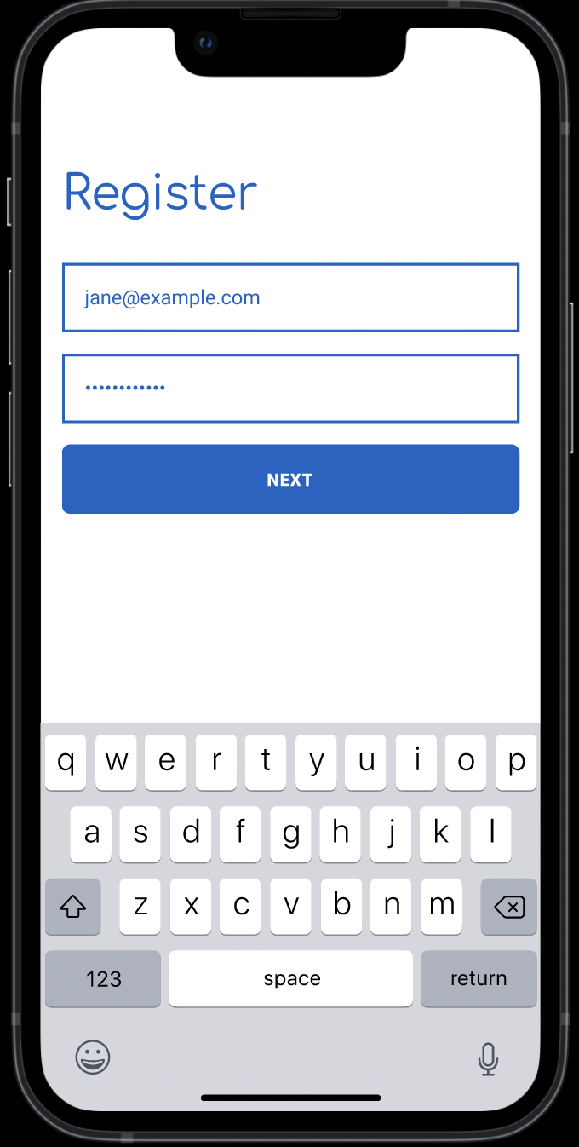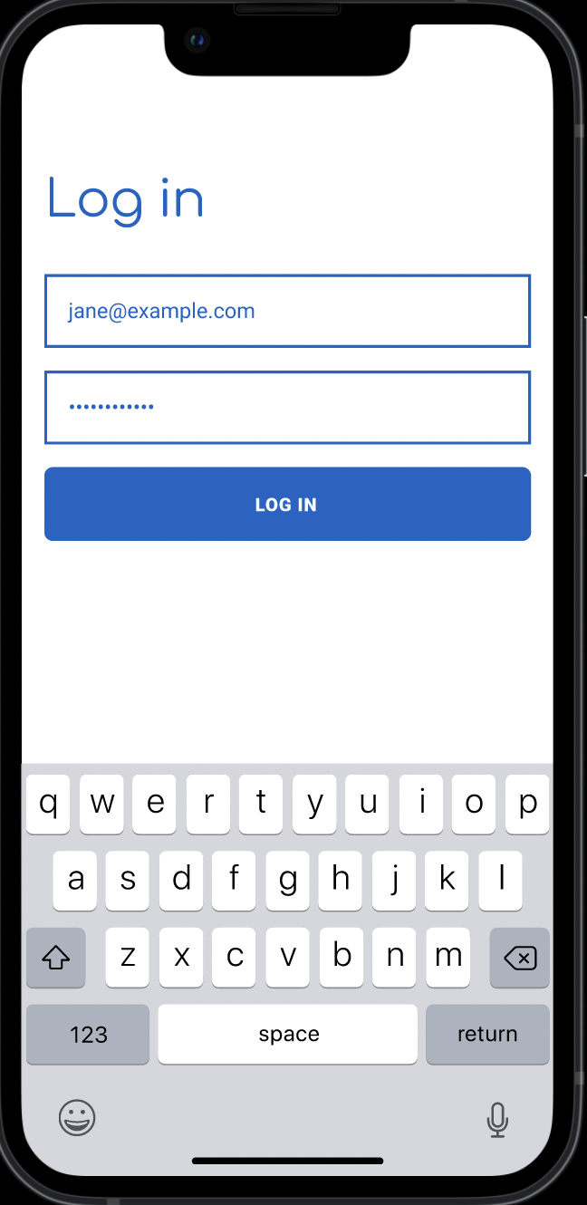

**How to create and review Resume**

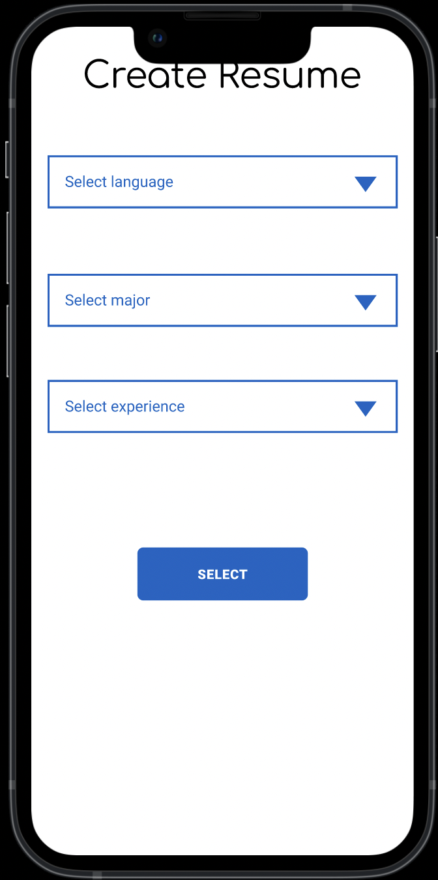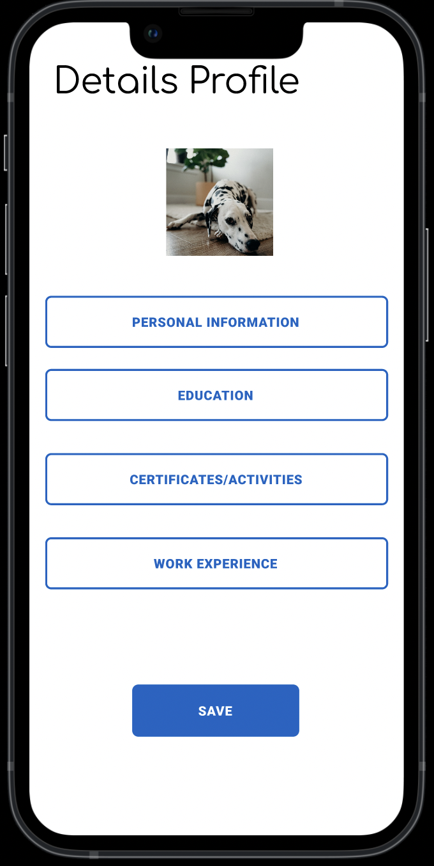

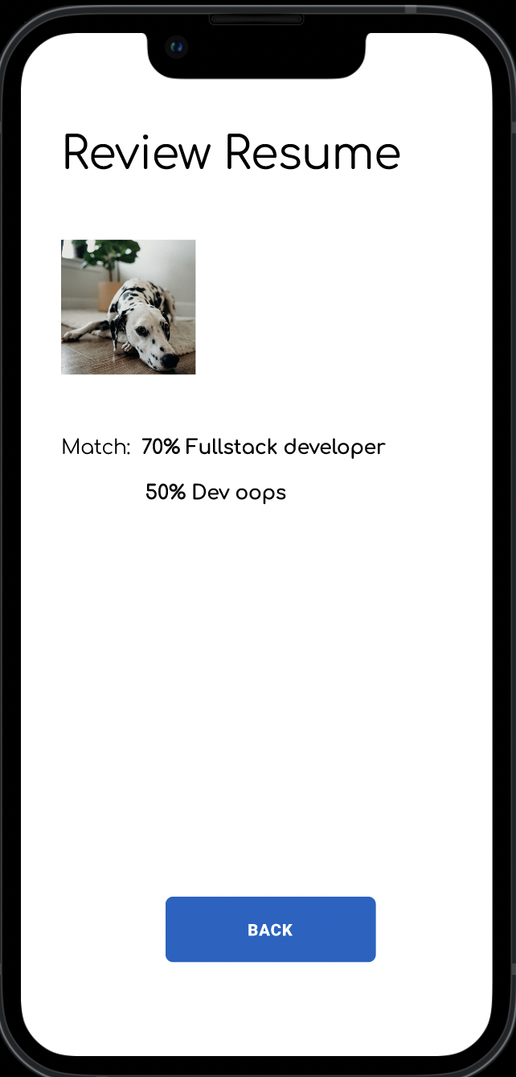

**How to apply a job from recommendation**